

**CS23332 DATABASE MANAGEMENT**

**SYSTEMS LAB**

**GYM MANAGEMENT SYSTEM**

**A MINI PROJECT REPORT**

| **Submitted** | **by** |  |
| --- | --- | --- |
| **NIKASH K G** |  | **231501108** |
| **NIRANJAN C** |  | **231501111** |
| **NITISH BALAJI B** |  | **231501115** |
|  |  |  |

In partial fulfillment for the award of the degree of

BACHELOR OF ENGINEERING IN

ARTIFICIAL INTELLIGENCE AND MACHINE LEARNING

RAJALAKSHMI ENGINEERING COLLEGE (AUTONOMOUS) THANDALAM

CHENNAI-602105

**2024 - 2025**



**BONAFIDE CERTIFICATE**

Certified that this project report “**GYM MANAGEMENT SYSTEM**” is the Bonafide work of **“NIKASH K G (231501108), NIRANJAN C (231501111), NITISH BALAJI B (231501115)”** who carried out the project work under my supervision.

Submitted for the Practical Examination held on _______________

**SIGNATURE**

**Mr. U. Kumaran,**

**Assistant Professor (SS)**

**AIML,**

**Rajalakshmi Engineering College**

**(Autonomous),**

**Thandalam, Chennai - 602 105**

**INTERNAL EXAMINER EXTERNAL EXAMINER**

**ABSTRACT**

This paper presents the design and implementation of a Gym Management System, a web-based application that automates various gym operations. The system leverages a MySQL database to store and manage critical information, including member details, payment history, and equipment inventory. The user-friendly interface, built using HTML and CSS, enables efficient member management, plan selection, payment processing, and notification delivery. By automating routine tasks and providing valuable insights, the system aims to streamline gym operations, improve member satisfaction, and enhance overall business efficiency.

Gym management system is a simple console application Mysql database for backend and HTML and CSS for the frontend.The User can perform basic Gym management operations like adding Members, Selecting various plans, Removing or Updating members Details, Making payments.

Each Member in the Gym has a unique identification number. The user can select the plans based on the given set of plans provided by the admin and select the equipment based on the availability.

When the user Subscription ends, the Administrator can send a Notification about the expiry so that the user can renew his/her payment on time.

**TABLE OF CONTENTS**

1. **INTRODUCTION**
   1. INTRODUCTION 1
   2. OBJECTIVES 2
   3. MODULES 2
2. **SURVEY OF TECHNOLOGIES**
   1. SOFTWARE DESCRIPTION 3
   2. LANGUAGES 3

2.2.1 HTML 3

2.2.2 CSS 3

2.2.3 PHP 4

2.2.4 MYSQL 4

1. **3. REQUIREMENTS AND ANALYSIS**

3.1 REQUIREMENT SPECIFICATION 5

3.2 HARDWARE AND SOFTWARE REQUIREMENTS 5

3.3 DATA FLOW DIAGRAM 6

3.4 DATA DICTIONARY 7

3.5 ER DIAGRAM 9

1. **PROGRAM CODE** 10
2. **RESULT AND DISCUSSION** 67
3. **TESTING**  72
4. **CONCLUSION** 76
5. **RESEARCH AND REFERENCE** 77

**CHAPTER 1**

**1.1 INTRODUCTION**

Managing a gym efficiently can be a complex task, involving various operations such as member management, payment processing, equipment maintenance, and more.

To streamline these processes and enhance the overall gym experience, a robust Gym Management System is essential. This system is designed to automate various tasks, improve efficiency, and provide a seamless experience for both gym members and staff.

**Key Features of the Gym Management System:**

* **Member Management:**
  + Add, edit, and delete member profiles
  + Track member attendance and workout history
  + Generate membership reports and statistics
* **Payment Processing:**
  + Online payment integration for convenient transactions
  + Track membership fees and other payments
  + Generate payment receipts and invoices
* **Equipment Management:**
  + Maintain an inventory of gym equipment
  + Schedule equipment maintenance and repairs
  + Track equipment usage and performance
* **Staff Management:**
  + Assign tasks and manage staff schedules
  + Monitor staff performance and track working hours
* **Member Portal:**
  + View membership plans and details
  + Make online payments
  + Book appointments and classes
  + Access workout routines and fitness tips

**1.2 OBJECTIVE**

The main objective of the Gym Management System is to manage the details of Members, Payments, Equipments, Staffs. It manages all the information about Members, Payments, Equipments, Staffs Effectively using Mysql Database. The project is totally built at the administrative end and thus only the administrator is guaranteed the access for now.

**1.3 MODULES**

* Add New Members
* View Members
* Update Member Details
* Make Payments
* Add Coach

**CHAPTER 2**

**2.1 SOFTWARE DESCRIPTION**

**Visual studio Code**

Visual Studio Code combines the simplicity of a source code editor with powerful developer tooling, like IntelliSense code completion and debugging. First and foremost, it is an editor that gets out of your way. The delightfully frictionless edit-build-debug cycle means less time fiddling with your environment, and more time executing on your ideas.

**2.2 LANGUAGES**

**2.2.1 HTML**

* **Hypertext**: text (often with embeds such as images, too) that is organized in order to connect related items
* **Markup**: a style guide for typesetting anything to be printed in hardcopy or soft copy format
* **Language**: a language that a computer system understands and uses to interpret commands.
* HTML determines the structure of web pages. This structure alone is not enough to make a web page look good and interactive. So you'll use assisted technologies such as CSS and JavaScript to make your HTML beautiful and add interactivity, respectively

**2.2.2 CSS**

CSS handles the look and feel part of a web page. Using CSS, you can control the color of the text, the style of fonts, the spacing between paragraphs, how columns are sized and laid out, what background images or colors are used, layout designs,variations in display for different devices and screen sizes as well as a variety of other effects.

**2.2.3 PHP**

PHP is a server side scripting language. that is used to develop Static websites or Dynamic websites or Web applications. PHP stands for Hypertext Preprocessor, which earlier stood for Personal Home Pages. PHP scripts can only be interpreted on a server that has PHP installed. The client computers accessing the PHP scripts require a web browser only.

**2.2.4 MySQL**

Many of the world's largest and fastest-growing organizations including Facebook, Google, Adobe, Alcatel Lucent and Zappos rely on MySQL to save time and money powering their high-volume Web sites, business-critical systems and packaged software. Since then, the performance & scalability, reliability, and ease of use of the world's most popular open source database, characteristics that made MySQL the #1 choice for web applications, have relentlessly been improved.

**CHAPTER 3**

**3.1 REQUIREMENTS SPECIFICATION**

**User Requirements**

The system requirement in library management focuses on the possibility of search for books by title, author or subject by the member.

**System Requirements**

There should be a database backup of the library management system. Operating system should be WindowsXP or a higher version of windows.

**3.2 HARDWARE AND SOFTWARE REQUIREMENTS**

**Software Requirements**

* Operating System Windows 10
* Front End HTML , CSS , javascript
* Back End PHP, MySQL

**Hardware Requirements**

* Desktop PC or a Laptop
* Operating System – Windows 10
* Intel® CoreTM i3-6006U CPU @ 2.00GHz
* 4.00 GB RAM
* 64-bit operating system, x64 based processor
* 1024 x 768 monitor resolution
* Keyboard and Mouse

**3.3 DATA FLOW DIAGRAM**

DFD is an important tool used by system analysis. A data flow diagram model, a system using external entities from which data flows through a process which transforms the data and creates output data transforms which go to other processes external entities such as files. The main merit of DFD is that it can provide an overview of what data a system would process.

* A data-flow diagram is a way of representing a flow of data through a process or a system.
* The DFD also provides information about the outputs and inputs of each entity and the process itself.

**CONTEXT LEVEL DFD:**

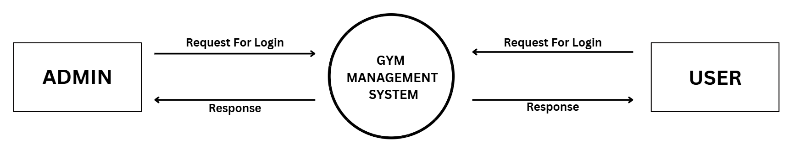

**3.4 DATA DICTIONARY**

**Members:**

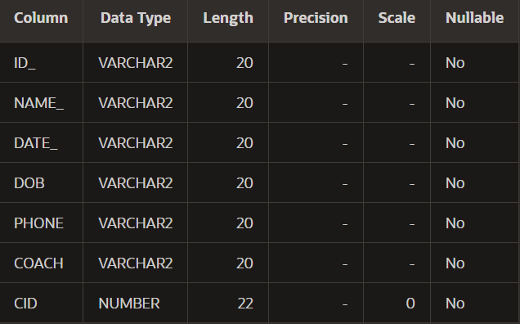

**Billing:**

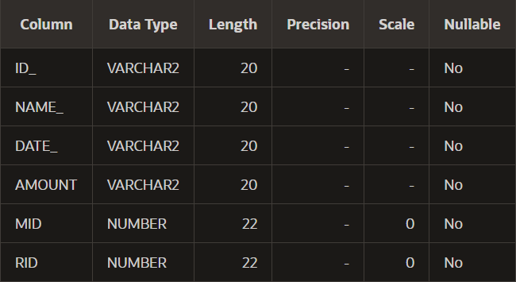

**Coach:**

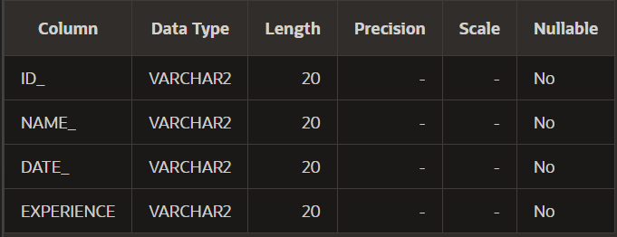

**Receptionist:**

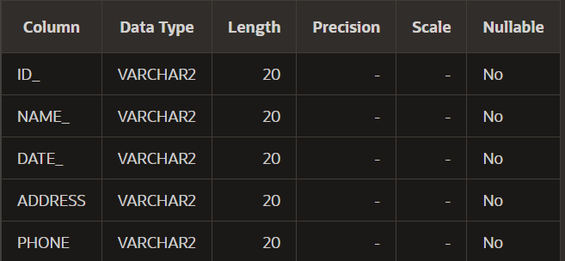

**3.5 ER DIAGRAM**

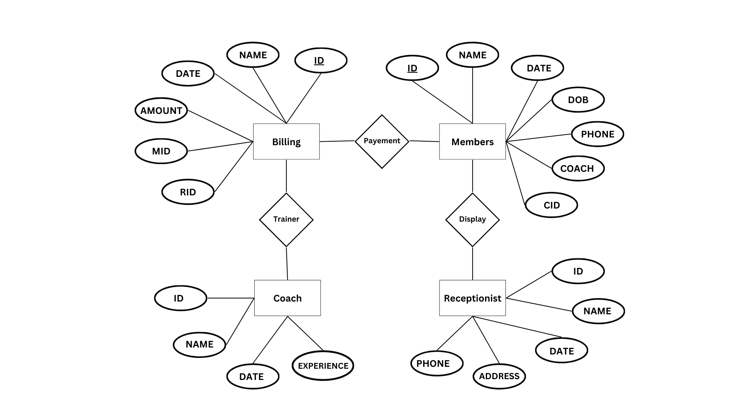

**CHAPTER 4**

**4.1 PROGRAM CODE**

**Home page:**

<!doctype html>

<html class="no-js" lang="zxx">

<head>

    <meta charset="utf-8">

    <meta http-equiv="x-ua-compatible" content="ie=edge">

    <title>Gym trainer | Template </title>

    <meta name="description" content="">

    <meta name="viewport" content="width=device-width, initial-scale=1">

    <link rel="manifest" href="site.webmanifest">

    <link rel="shortcut icon" type="image/x-icon" href="assets/img/favicon.ico">

    <!-- CSS here -->

    <link rel="stylesheet" href="css\bootstrap.min.css">

    <link rel="stylesheet" href="css\owl.carousel.min.css">

    <link rel="stylesheet" href="css\slicknav.css">

    <link rel="stylesheet" href="css\flaticon.css">

    <link rel="stylesheet" href="css\gijgo.css">

    <link rel="stylesheet" href="css\animate.min.css">

    <link rel="stylesheet" href="css\animated-headline.css">

    <link rel="stylesheet" href="css\magnific-popup.css">

    <link rel="stylesheet" href="css\fontawesome-all.min.css">

    <link rel="stylesheet" href="css\themify-icons.css">

    <link rel="stylesheet" href="css\slick.css">

    <link rel="stylesheet" href="css\nice-select.css">

    <link rel="stylesheet" href="css\style.css">

</head>

<body class="black-bg">

    <!-- ? Preloader Start -->

    <div id="preloader-active">

        <div class="preloader d-flex align-items-center justify-content-center">

            <div class="preloader-inner position-relative">

                <div class="preloader-circle"></div>

                <div class="preloader-img pere-text">

                    <img src="img/TT.png" alt="">

                </div>

            </div>

        </div>

    </div>

    <!-- Preloader Start -->

    <header>

        <!-- Header Start -->

        <div class="header-area header-transparent">

            <div class="main-header header-sticky">

                <div class="container-fluid">

                    <div class="menu-wrapper d-flex align-items-center justify-content-between">

                        <!-- Logo -->

                        <div class="logo">

                            <a href="index.html"><img src="img/TT.png" alt=""></a>

                        </div>

                        <!-- Main-menu -->

                        <div class="main-menu f-right d-none d-lg-block">

                            <nav>

                                <ul id="navigation">

                                    <li><a href="index.html">Home</a></li>

                                    <li><a href="about.html">About</a></li>

                                    <li><a href="pricing.html">Pricing</a></li>

                                    <li><a href="blog.html">Blog</a>

                                    </li>

                                    <li><a href="contact.html">Contact</a></li>

                                </ul>

                            </nav>

                        </div>

                        <!-- Header-btn -->

                        <div class="header-btns d-none d-lg-block f-right">

                           <a href="admin-login.php" class="btn">Admin</a>

                       </div>

                       <!-- Mobile Menu -->

                       <div class="col-12">

                        <div class="mobile_menu d-block d-lg-none"></div>

                    </div>

                </div>

            </div>

        </div>

    </div>

    <!-- Header End -->

</header>

<main>

    <!--? slider Area Start-->

    <div class="slider-area position-relative">

        <div class="slider-active">

            <!-- Single Slider -->

            <div class="single-slider slider-height d-flex align-items-center">

                <div class="container">

                    <div class="row">

                        <div class="col-xl-9 col-lg-9 col-md-10">

                            <div class="hero__caption">

                                <h1 data-animation="fadeInLeft" data-delay="0.4s">FitSpire</h1>

                                <span data-animation="fadeInLeft" data-delay="0.1s">Fitspire, Level Up Your Fitness Game.</span>

                                <a href="pricing.html" class="border-btn hero-btn" data-animation="fadeInLeft" data-delay="0.8s">join now</a>

                            </div>

                        </div>

                    </div>

                </div>

            </div>

        </div>

    </div>

    <!-- slider Area End-->

    <!-- Traning categories Start -->

    <section class="traning-categories black-bg">

    </section>

    <!-- Traning categories End-->

    <!--? Team -->

    <section class="team-area fix">

        <div class="container">

            <div class="row">

                <div class="col-xl-12">

                    <div class="section-tittle text-center mb-55 wow fadeInUp" data-wow-duration="1s" data-wow-delay=".1s">

                        <h2 >What We Offer</h2>

                    </div>

                </div>

            </div>

            <div class="row">

                <div class="col-lg-4 col-md-6">

                    <div class="single-cat text-center mb-30 wow fadeInUp" data-wow-duration="1s" data-wow-delay=".2s" >

                        <div class="cat-icon">

                            <img src="assets/img/gallery/team1.png" alt="">

                        </div>

                        <div class="cat-cap">

                            <h5><a href="services.html">Body Building</a></h5>

                            <p>Power up your performance with our cutting-edge training techniques.</p>

                        </div>

                    </div>

                </div>

                <div class="col-lg-4 col-md-6">

                    <div class="single-cat text-center mb-30 wow fadeInUp" data-wow-duration="1s" data-wow-delay=".4s">

                        <div class="cat-icon">

                            <img src="assets/img/gallery/team2.png" alt="">

                        </div>

                        <div class="cat-cap">

                            <h5><a href="services.html">Muscle Gain</a></h5>

                            <p>Transform your body, transform your life through dedicated training and nutrition.</p>

                        </div>

                    </div>

                </div>

                <div class="col-lg-4 col-md-6">

                    <div class="single-cat text-center mb-30 wow fadeInUp" data-wow-duration="1s" data-wow-delay=".6s">

                        <div class="cat-icon">

                            <img src="assets/img/gallery/team3.png" alt="">

                        </div>

                        <div class="cat-cap">

                            <h5><a href="services.html">Weight Loss</a></h5>

                            <p>Lose weight, feel great with our personalized weight loss programs.</p>

                        </div>

                    </div>

                </div>

            </div>

        </div>

    </section>

    <!-- Services End -->

    <!--? Gallery Area Start -->

    <!-- Courses area start -->

    <section class="pricing-area section-padding40 fix">

        <div class="container">

            <div class="row">

                <div class="col-xl-12">

                    <div class="section-tittle text-center mb-55 wow fadeInUp" data-wow-duration="2s" data-wow-delay=".1s">

                        <h2>Pricing</h2>

                    </div>

                </div>

            </div>

            <div class="row">

                <div class="col-lg-4 col-md-6 col-sm-6">

                    <div class="properties mb-30 wow fadeInUp" data-wow-duration="1s" data-wow-delay=".2s">

                        <div class="properties__card">

                            <div class="about-icon">

                                <img src="assets/img/icon/price.svg" alt="">

                            </div>

                            <div class="properties__caption">

                                <span class="month">1 month</span>

                                <p class="mb-25">₹1500 <span>(Basic Membership)</span></p>

                                <div class="single-features">

                                    <div class="features-icon">

                                        <img src="assets/img/icon/check.svg" alt="">

                                    </div>

                                    <div class="features-caption">

                                        <p>Unlimited Gym Access </p>

                                    </div>

                                </div>

                                <div class="single-features">

                                    <div class="features-icon">

                                        <img src="assets/img/icon/check.svg" alt="">

                                    </div>

                                    <div class="features-caption">

                                        <p>Basic Fitness Classes </p>

                                    </div>

                                </div>

                                <div class="single-features">

                                    <div class="features-icon">

                                        <img src="assets/img/icon/check.svg" alt="">

                                    </div>

                                    <div class="features-caption">

                                        <p>Personal trainer</p>

                                    </div>

                                </div>

                                <div class="single-features">

                                    <div class="features-icon">

                                        <img src="assets/img/icon/check.svg" alt="">

                                    </div>

                                    <div class="features-caption">

                                        <p>Access to Gym Equipment</p>

                                    </div>

                                </div>

                                <div class="single-features mb-20">

                                    <div class="features-icon">

                                        <img src="assets/img/icon/check.svg" alt="">

                                    </div>

                                    <div class="features-caption">

                                        <p>Month to Month Flexibility</p>

                                    </div>

                                </div>

                                <a href="#" class="border-btn border-btn2">Join now</a>

                            </div>

                        </div>

                    </div>

                </div>

                <div class="col-lg-4 col-md-6 col-sm-6">

                    <div class="properties mb-30 wow fadeInUp" data-wow-duration="1s" data-wow-delay=".4s">

                        <div class="properties__card">

                            <div class="about-icon">

                                <img src="assets/img/icon/price.svg" alt="">

                            </div>

                            <div class="properties__caption">

                                <span class="month">6 month</span>

                                <p class="mb-25">₹9000<span>(Premium Membership)</span></p>

                                <div class="single-features">

                                    <div class="features-icon">

                                        <img src="assets/img/icon/check.svg" alt="">

                                    </div>

                                    <div class="features-caption">

                                        <p>Unlimited Gym Access</p>

                                    </div>

                                </div>

                                <div class="single-features">

                                    <div class="features-icon">

                                        <img src="assets/img/icon/check.svg" alt="">

                                    </div>

                                    <div class="features-caption">

                                        <p>Dedicated Personal Trainer</p>

                                    </div>

                                </div>

                                <div class="single-features">

                                    <div class="features-icon">

                                        <img src="assets/img/icon/check.svg" alt="">

                                    </div>

                                    <div class="features-caption">

                                        <p>Customized Workout Plans</p>

                                    </div>

                                </div>

                                <div class="single-features">

                                    <div class="features-icon">

                                        <img src="assets/img/icon/check.svg" alt="">

                                    </div>

                                    <div class="features-caption">

                                        <p>Nutritional Guidance</p>

                                    </div>

                                </div>

                                <div class="single-features mb-20">

                                    <div class="features-icon">

                                        <img src="assets/img/icon/check.svg" alt="">

                                    </div>

                                    <div class="features-caption">

                                        <p>Month-to-Month Flexibility</p>

                                    </div>

                                </div>

                                <a href="#" class="border-btn border-btn2">Join Now</a>

                            </div>

                        </div>

                    </div>

                </div>

                <div class="col-lg-4 col-md-6 col-sm-6">

                    <div class="properties mb-30 wow fadeInUp" data-wow-duration="1s" data-wow-delay=".6s">

                        <div class="properties__card">

                            <div class="about-icon">

                                <img src="assets/img/icon/price.svg" alt="">

                            </div>

                            <div class="properties__caption">

                                <span class="month">Annual plan</span>

                                <p class="mb-25">₹15000  <span>(Elite Membership)</span></p>

                                <div class="single-features">

                                    <div class="features-icon">

                                        <img src="assets/img/icon/check.svg" alt="">

                                    </div>

                                    <div class="features-caption">

                                        <p>Free riding </p>

                                    </div>

                                </div>

                                <div class="single-features">

                                    <div class="features-icon">

                                        <img src="assets/img/icon/check.svg" alt="">

                                    </div>

                                    <div class="features-caption">

                                        <p> Unlimited Gym Access</p>

                                    </div>

                                </div>

                                <div class="single-features">

                                    <div class="features-icon">

                                        <img src="assets/img/icon/check.svg" alt="">

                                    </div>

                                    <div class="features-caption">

                                        <p>Weight Loss Support Groups</p>

                                    </div>

                                </div>

                                <div class="single-features">

                                    <div class="features-icon">

                                        <img src="assets/img/icon/check.svg" alt="">

                                    </div>

                                    <div class="features-caption">

                                        <p>Dedicated Personal Trainer

                                        </p>

                                    </div>

                                </div>

                                <div class="single-features mb-20">

                                    <div class="features-icon">

                                        <img src="assets/img/icon/check.svg" alt="">

                                    </div>

                                    <div class="features-caption">

                                        <p>Customized Workout Plans</p>

                                    </div>

                                </div>

                                <a href="#" class="border-btn border-btn2">Join Now</a>

                            </div>

                        </div>

                    </div>

                </div>

            </div>

        </div>

    </section>

    <!-- Courses area End -->

    <!--? About Area-2 Start -->

    <section class="about-area2 fix pb-padding pt-50 pb-80">

        <div class="support-wrapper align-items-center">

            <div class="right-content2">

                <!-- img -->

                <div class="right-img wow fadeInUp" data-wow-duration="1s" data-wow-delay=".1s">

                    <img src="assets/img/gallery/about.png" alt="">

                </div>

            </div>

            <div class="left-content2">

                <!-- section tittle -->

                <div class="section-tittle2 mb-20 wow fadeInUp" data-wow-duration="1s" data-wow-delay=".3s">

                    <div class="front-text">

                        <h2 class="">About Me</h2>

                        <p>Elevate your fitness journey with Fitspire. Our state-of-the-art facility, coupled with expert guidance, empowers you to achieve your fitness goals. Whether you're a seasoned athlete or a beginner, our personalized training programs and diverse fitness classes cater to all levels. From high-intensity workouts to calming yoga sessions, we offer a comprehensive range of services to help you stay fit and healthy. Join the Fitspire community and experience the transformation.</p>

                        <a href="pricing.html" class="border-btn">join now</a>

                    </div>

                </div>

            </div>

        </div>

    </section>

    <!-- About Area End -->

    <!-- Blog Area End -->

    <!-- ? services-area -->

    <section class="services-area">

        <div class="container">

            <div class="row justify-content-between">

                <div class="col-xl-4 col-lg-4 col-md-6 col-sm-8">

                    <div class="single-services mb-40 wow fadeInUp" data-wow-duration="1s" data-wow-delay=".1s">

                        <div class="features-icon">

                            <img src="assets/img/icon/icon1.svg" alt="">

                        </div>

                        <div class="features-caption">

                            <h3>Location</h3>

                            <p>Rajalakshmi Engineering College</p>

                        </div>

                    </div>

                </div>

                <div class="col-xl-3 col-lg-4 col-md-6 col-sm-8">

                    <div class="single-services mb-40 wow fadeInUp" data-wow-duration="1s" data-wow-delay=".2s">

                        <div class="features-icon">

                            <img src="assets/img/icon/icon2.svg" alt="">

                        </div>

                        <div class="features-caption">

                            <h3>Phone</h3>

                            <p>(90) 277 278 2566</p>

                            <p>  (78) 267 256 2578</p>

                        </div>

                    </div>

                </div>

                <div class="col-xl-3 col-lg-4 col-md-6 col-sm-8">

                    <div class="single-services mb-40 wow fadeInUp" data-wow-duration="2s" data-wow-delay=".4s">

                        <div class="features-icon">

                            <img src="assets/img/icon/icon3.svg" alt="">

                        </div>

                        <div class="features-caption">

                            <h3>Email</h3>

                            <p>Fitspire@gmail.com</p>

                            <p>Fitspirefit@gmail.com</p>

                        </div>

                    </div>

                </div>

            </div>

        </div>

    </section>

</main>

<footer>

    <!--? Footer Start-->

    <div class="footer-area black-bg">

        <div class="container">

            <div class="footer-top footer-padding">

                <!-- Footer Menu -->

                <div class="row">

                    <div class="col-xl-12">

                        <div class="single-footer-caption mb-50 text-center">

                            <!-- logo -->

                            <div class="footer-logo wow fadeInUp" data-wow-duration="1s" data-wow-delay=".2s">

                                <a href="index.html"><img src="img/TT.png" alt=""></a>

                            </div>

                            <!-- Menu -->

                            <!-- Header Start -->

                            <div class="header-area main-header2 wow fadeInUp" data-wow-duration="2s" data-wow-delay=".4s">

                                <div class="main-header main-header2">

                                    <div class="menu-wrapper menu-wrapper2">

                                        <!-- Main-menu -->

                                        <div class="main-menu main-menu2 text-center">

                                            <nav>

                                                <ul>

                                                    <li><a href="index.html">Home</a></li>

                                                    <li><a href="about.html">About</a></li>

                                                    <li><a href="courses.html">Courses</a></li>

                                                    <li><a href="pricing.html">Pricing</a></li>

                                                    <li><a href="contact.html">Contact</a></li>

                                                </ul>

                                            </nav>

                                        </div>

                                    </div>

                                </div>

                            </div>

                            <!-- Header End -->

            <!-- Footer Bottom -->

            <div class="footer-bottom">

                <div class="row d-flex align-items-center">

                    <div class="col-lg-12">

                        <div class="footer-copy-right text-center">

                            <p><!-- Link back to Colorlib can't be removed. Template is licensed under CC BY 3.0. -->

                              Copyright &copy;<script>document.write(new Date().getFullYear());</script> All rights reserved | <i class="fa fa-heart" aria-hidden="true"></i>  <a href="https://www.TuitionsTonight.com" target="_blank">Fitspire</a>

                              <!-- Link back to Colorlib can't be removed. Template is licensed under CC BY 3.0. --></p>

                          </div>

                      </div>

                  </div>

              </div>

          </div>

      </div>

      <!-- Footer End-->

  </footer>

  <!-- Scroll Up -->

  <div id="back-top" >

    <a title="Go to Top" href="#"> <i class="fas fa-level-up-alt"></i></a>

</div>

<!-- JS here -->

<script src="./assets/js/vendor/modernizr-3.5.0.min.js"></script>

<!-- Jquery, Popper, Bootstrap -->

<script src="./assets/js/vendor/jquery-1.12.4.min.js"></script>

<script src="./assets/js/popper.min.js"></script>

<script src="./assets/js/bootstrap.min.js"></script>

<!-- Jquery Mobile Menu -->

<script src="./assets/js/jquery.slicknav.min.js"></script>

<!-- Jquery Slick , Owl-Carousel Plugins -->

<script src="./assets/js/owl.carousel.min.js"></script>

<script src="./assets/js/slick.min.js"></script>

<!-- One Page, Animated-HeadLin -->

<script src="./assets/js/wow.min.js"></script>

<script src="./assets/js/animated.headline.js"></script>

<script src="./assets/js/jquery.magnific-popup.js"></script>

<!-- Date Picker -->

<script src="./assets/js/gijgo.min.js"></script>

<!-- Nice-select, sticky -->

<script src="./assets/js/jquery.nice-select.min.js"></script>

<script src="./assets/js/jquery.sticky.js"></script>

<!-- counter , waypoint,Hover Direction -->

<script src="./assets/js/jquery.counterup.min.js"></script>

<script src="./assets/js/waypoints.min.js"></script>

<script src="./assets/js/jquery.countdown.min.js"></script>

<script src="./assets/js/hover-direction-snake.min.js"></script>

<!-- contact js -->

<script src="./assets/js/contact.js"></script>

<script src="./assets/js/jquery.form.js"></script>

<script src="./assets/js/jquery.validate.min.js"></script>

<script src="./assets/js/mail-script.js"></script>

<script src="./assets/js/jquery.ajaxchimp.min.js"></script>

<!-- Jquery Plugins, main Jquery -->

<script src="./assets/js/plugins.js"></script>

<script src="./assets/js/main.js"></script>

</body>

</html>

**About us page:**

<!doctype html>

<html class="no-js" lang="zxx">

<head>

    <meta charset="utf-8">

    <meta http-equiv="x-ua-compatible" content="ie=edge">

    <title>Gym trainer | Template </title>

    <meta name="description" content="">

    <meta name="viewport" content="width=device-width, initial-scale=1">

    <link rel="manifest" href="site.webmanifest">

    <link rel="shortcut icon" type="image/x-icon" href="assets/img/favicon.ico">

    <!-- CSS here -->

    <link rel="stylesheet" href="assets/css/bootstrap.min.css">

    <link rel="stylesheet" href="assets/css/owl.carousel.min.css">

    <link rel="stylesheet" href="assets/css/slicknav.css">

    <link rel="stylesheet" href="assets/css/flaticon.css">

    <link rel="stylesheet" href="assets/css/gijgo.css">

    <link rel="stylesheet" href="assets/css/animate.min.css">

    <link rel="stylesheet" href="assets/css/animated-headline.css">

    <link rel="stylesheet" href="assets/css/magnific-popup.css">

    <link rel="stylesheet" href="assets/css/fontawesome-all.min.css">

    <link rel="stylesheet" href="assets/css/themify-icons.css">

    <link rel="stylesheet" href="assets/css/slick.css">

    <link rel="stylesheet" href="assets/css/nice-select.css">

    <link rel="stylesheet" href="assets/css/style.css">

</head>

<body class="black-bg">

    <!-- ? Preloader Start -->

    <div id="preloader-active">

        <div class="preloader d-flex align-items-center justify-content-center">

            <div class="preloader-inner position-relative">

                <div class="preloader-circle"></div>

                <div class="preloader-img pere-text">

                    <img src="img/TT.png" alt="">

                </div>

            </div>

        </div>

    </div>

    <!-- Preloader Start -->

    <header>

        <!-- Header Start -->

        <div class="header-area header-transparent">

            <div class="main-header header-sticky">

                <div class="container-fluid">

                    <div class="menu-wrapper d-flex align-items-center justify-content-between">

                        <!-- Logo -->

                        <div class="logo">

                            <a href="index.html"><img src="img/TT.png" alt=""></a>

                        </div>

                        <!-- Main-menu -->

                        <div class="main-menu f-right d-none d-lg-block">

                            <nav>

                                <ul id="navigation">

                                    <li><a href="index.html">Home</a></li>

                                    <li><a href="about.html">About</a></li>

                                    <li><a href="pricing.html">Pricing</a></li>

                                    <li><a href="contact.html">Contact</a></li>

                                </ul>

                            </nav>

                        </div>

                        <!-- Header-btn -->

                        <div class="header-btns d-none d-lg-block f-right">

                           <a href="admin-login.php" class="btn">Admin</a>

                       </div>

                       <!-- Mobile Menu -->

                       <div class="col-12">

                        <div class="mobile_menu d-block d-lg-none"></div>

                    </div>

                </div>

            </div>

        </div>

    </div>

    <!-- Header End -->

</header>

<main>

    <section class="team-area fix">

        <div class="container">

            <div class="row">

                <div class="col-xl-12">

                    <div class="section-tittle text-center mb-55 wow fadeInUp" data-wow-duration="1s" data-wow-delay=".1s">

                        <h2 >What We Offer</h2>

                    </div>

                </div>

            </div>

            <div class="row">

                <div class="col-lg-4 col-md-6">

                    <div class="single-cat text-center mb-30 wow fadeInUp" data-wow-duration="1s" data-wow-delay=".2s" >

                        <div class="cat-icon">

                            <img src="assets/img/gallery/team1.png" alt="">

                        </div>

                        <div class="cat-cap">

                            <h5><a href="services.html">Body Building</a></h5>

                            <p>Power up your performance with our cutting-edge training techniques.</p>

                        </div>

                    </div>

                </div>

                <div class="col-lg-4 col-md-6">

                    <div class="single-cat text-center mb-30 wow fadeInUp" data-wow-duration="1s" data-wow-delay=".4s">

                        <div class="cat-icon">

                            <img src="assets/img/gallery/team2.png" alt="">

                        </div>

                        <div class="cat-cap">

                            <h5><a href="services.html">Muscle Gain</a></h5>

                            <p>Transform your body, transform your life through dedicated training and nutrition.</p>

                        </div>

                    </div>

                </div>

                <div class="col-lg-4 col-md-6">

                    <div class="single-cat text-center mb-30 wow fadeInUp" data-wow-duration="1s" data-wow-delay=".6s">

                        <div class="cat-icon">

                            <img src="assets/img/gallery/team3.png" alt="">

                        </div>

                        <div class="cat-cap">

                            <h5><a href="services.html">Weight Loss</a></h5>

                            <p>Lose weight, feel great with our personalized weight loss programs.</p>

                        </div>

                    </div>

                </div>

            </div>

        </div>

    </section>

    <!-- Services End -->

      <!--? About Area-2 Start -->

    <section class="about-area2 fix pb-padding pt-50 pb-80">

        <div class="support-wrapper align-items-center">

            <div class="right-content2">

                <!-- img -->

                <div class="right-img wow fadeInUp" data-wow-duration="1s" data-wow-delay=".1s">

                    <img src="assets/img/gallery/about.png" alt="">

                </div>

            </div>

            <div class="left-content2">

                <!-- section tittle -->

                <div class="section-tittle2 mb-20 wow fadeInUp" data-wow-duration="1s" data-wow-delay=".3s">

                    <div class="front-text">

                        <h2 class="">About Me</h2>

                        <p>Elevate your fitness journey with Fitspire. Our state-of-the-art facility, coupled with expert guidance, empowers you to achieve your fitness goals. Whether you're a seasoned athlete or a beginner, our personalized training programs and diverse fitness classes cater to all levels. From high-intensity workouts to calming yoga sessions, we offer a comprehensive range of services to help you stay fit and healthy. Join the Fitspire community and experience the transformation.</p>

                        <a href="pricing.html" class="border-btn">join now</a>

                    </div>

                </div>

            </div>

        </div>

    </section>

    <!-- About Area End -->

    <!-- Blog Area End -->

    <!-- ? services-area -->

    <section class="services-area">

        <div class="container">

            <div class="row justify-content-between">

                <div class="col-xl-4 col-lg-4 col-md-6 col-sm-8">

                    <div class="single-services mb-40 wow fadeInUp" data-wow-duration="1s" data-wow-delay=".1s">

                        <div class="features-icon">

                            <img src="assets/img/icon/icon1.svg" alt="">

                        </div>

                        <div class="features-caption">

                            <h3>Location</h3>

                            <p>Rajalakshmi Engineering College</p>

                        </div>

                    </div>

                </div>

                <div class="col-xl-3 col-lg-4 col-md-6 col-sm-8">

                    <div class="single-services mb-40 wow fadeInUp" data-wow-duration="1s" data-wow-delay=".2s">

                        <div class="features-icon">

                            <img src="assets/img/icon/icon2.svg" alt="">

                        </div>

                        <div class="features-caption">

                            <h3>Phone</h3>

                            <p>(90) 277 278 2566</p>

                            <p>  (78) 267 256 2578</p>

                        </div>

                    </div>

                </div>

                <div class="col-xl-3 col-lg-4 col-md-6 col-sm-8">

                    <div class="single-services mb-40 wow fadeInUp" data-wow-duration="2s" data-wow-delay=".4s">

                        <div class="features-icon">

                            <img src="assets/img/icon/icon3.svg" alt="">

                        </div>

                        <div class="features-caption">

                            <h3>Email</h3>

                            <p>Fitspire@gmail.com</p>

                            <p>Fitspirefit@gmail.com</p>

                        </div>

                    </div>

                </div>

            </div>

        </div>

    </section>

</main>

<footer>

    <!--? Footer Start-->

    <div class="footer-area black-bg">

        <div class="container">

            <div class="footer-top footer-padding">

                <!-- Footer Menu -->

                <div class="row">

                    <div class="col-xl-12">

                        <div class="single-footer-caption mb-50 text-center">

                            <!-- logo -->

                            <div class="footer-logo wow fadeInUp" data-wow-duration="1s" data-wow-delay=".2s">

                                <a href="index.html"><img src="img/TT.png" alt=""></a>

                            </div>

                            <!-- Menu -->

                            <!-- Header Start -->

                            <div class="header-area main-header2 wow fadeInUp" data-wow-duration="2s" data-wow-delay=".4s">

                                <div class="main-header main-header2">

                                    <div class="menu-wrapper menu-wrapper2">

                                        <!-- Main-menu -->

                                        <div class="main-menu main-menu2 text-center">

                                            <nav>

                                                <ul>

                                                    <li><a href="index.html">Home</a></li>

                                                    <li><a href="about.html">About</a></li>

                                                    <li><a href="courses.html">Courses</a></li>

                                                    <li><a href="pricing.html">Pricing</a></li>

                                                    <li><a href="contact.html">Contact</a></li>

                                                </ul>

                                            </nav>

                                        </div>

                                    </div>

                                </div>

                            </div>

                            <!-- Header End -->

            <!-- Footer Bottom -->

            <div class="footer-bottom">

                <div class="row d-flex align-items-center">

                    <div class="col-lg-12">

                        <div class="footer-copy-right text-center">

                            <p><!-- Link back to Colorlib can't be removed. Template is licensed under CC BY 3.0. -->

                              Copyright &copy;<script>document.write(new Date().getFullYear());</script> All rights reserved | <i class="fa fa-heart" aria-hidden="true"></i>  <a href="https://www.TuitionsTonight.com" target="_blank">Fitspire</a>

                              <!-- Link back to Colorlib can't be removed. Template is licensed under CC BY 3.0. --></p>

                          </div>

                      </div>

                  </div>

              </div>

          </div>

      </div>

      <!-- Footer End-->

  </footer>

  <!-- Scroll Up -->

  <div id="back-top" >

    <a title="Go to Top" href="#"> <i class="fas fa-level-up-alt"></i></a>

</div>

<!-- JS here -->

<script src="./assets/js/vendor/modernizr-3.5.0.min.js"></script>

<!-- Jquery, Popper, Bootstrap -->

<script src="./assets/js/vendor/jquery-1.12.4.min.js"></script>

<script src="./assets/js/popper.min.js"></script>

<script src="./assets/js/bootstrap.min.js"></script>

<!-- Jquery Mobile Menu -->

<script src="./assets/js/jquery.slicknav.min.js"></script>

<!-- Jquery Slick , Owl-Carousel Plugins -->

<script src="./assets/js/owl.carousel.min.js"></script>

<script src="./assets/js/slick.min.js"></script>

<!-- One Page, Animated-HeadLin -->

<script src="./assets/js/wow.min.js"></script>

<script src="./assets/js/animated.headline.js"></script>

<script src="./assets/js/jquery.magnific-popup.js"></script>

<!-- Date Picker -->

<script src="./assets/js/gijgo.min.js"></script>

<!-- Nice-select, sticky -->

<script src="./assets/js/jquery.nice-select.min.js"></script>

<script src="./assets/js/jquery.sticky.js"></script>

<!-- counter , waypoint,Hover Direction -->

<script src="./assets/js/jquery.counterup.min.js"></script>

<script src="./assets/js/waypoints.min.js"></script>

<script src="./assets/js/jquery.countdown.min.js"></script>

<script src="./assets/js/hover-direction-snake.min.js"></script>

<!-- contact js -->

<script src="./assets/js/contact.js"></script>

<script src="./assets/js/jquery.form.js"></script>

<script src="./assets/js/jquery.validate.min.js"></script>

<script src="./assets/js/mail-script.js"></script>

<script src="./assets/js/jquery.ajaxchimp.min.js"></script>

<!-- Jquery Plugins, main Jquery -->

<script src="./assets/js/plugins.js"></script>

<script src="./assets/js/main.js"></script>

</body>

</html>

**Login Page:**

<?php

if (isset($_POST ["submit"])){

$username = $_POST['user'];

$password = $_POST['pass'];

if($username == 'admin' && $password == "password"){

header("Location: Billing.php");

}

else{

echo "Username or Password is incorrect!";

}

}

?>

<!DOCTYPE html>

<html lang="en">

<head>

<meta charset="UTF-8">

<meta http-equiv="X-UA-Compatible" content="IE=edge">

<meta name="viewport" content="width=device-width, initial-scale=1.0">

<title>Document</title>

<link rel="shortcut icon" type="image/x-icon" href="assets/img/favicon.ico">

<style>img{

width: 100%;

}

.login {

height: 1000px;

width: 100%;

background: radial-gradient(#653d84, #332042);

position: relative;

}

.login_box {

width: 1050px;

height: 600px;

position: absolute;

top: 50%;

left: 50%;

transform: translate(-50%,-50%);

background: #fff;

border-radius: 10px;

box-shadow: 1px 4px 22px -8px #0004;

display: flex;

overflow: hidden;

}

.login_box .left{

width: 41%;

height: 100%;

padding: 25px 25px;

}

.login_box .right{

width: 59%;

height: 100%

}

.left .top_link a {

color: #452A5A;

font-weight: 400;

}

.left .top_link{

height: 20px

}

.left .contact{

display: flex;

align-items: center;

justify-content: center;

align-self: center;

height: 100%;

width: 73%;

margin: auto;

}

.left h3{

text-align: center;

margin-bottom: 40px;

}

.left input {

border: none;

width: 80%;

margin: 15px 0px;

border-bottom: 1px solid #4f30677d;

padding: 7px 9px;

width: 100%;

overflow: hidden;

background: transparent;

font-weight: 600;

font-size: 14px;

}

.left{

background: linear-gradient(-45deg, #dcd7e0, #fff);

}

.submit {

border: none;

padding: 15px 70px;

border-radius: 8px;

display: block;

margin: auto;

margin-top: 120px;

background: #583672;

color: #fff;

font-weight: bold;

-webkit-box-shadow: 0px 9px 15px -11px rgba(88,54,114,1);

-moz-box-shadow: 0px 9px 15px -11px rgba(88,54,114,1);

box-shadow: 0px 9px 15px -11px rgba(88,54,114,1);

}

.right {

background: linear-gradient(212.38deg, rgba(2,2,2, 0.7) 0%, rgba(175, 70, 189, 0.71) 100%),url('img/gallery5.png');

color: #fff;

position: relative;

}

.right .right-text{

height: 100%;

position: relative;

transform: translate(0%, 45%);

}

.right-text h2{

display: block;

width: 100%;

text-align: center;

font-size: 50px;

font-weight: 500;

}

.right-text h5{

display: block;

width: 100%;

text-align: center;

font-size: 19px;

font-weight: 400;

}

.right .right-inductor{

position: absolute;

width: 70px;

height: 7px;

background: #fff0;

left: 50%;

bottom: 70px;

transform: translate(-50%, 0%);

}

.top_link img {

width: 28px;

padding-right: 7px;

margin-top: -3px;

}

</style>

</head>

<body>

<section class="login">

<div class="login_box">

<div class="left">

<div class="top_link"><a href="index.html"><img src="https://drive.google.com/u/0/uc?id=16U__U5dJdaTfNGobB_OpwAJ73vM50rPV&export=download" alt="">Return home</a></div>

<div class="contact">

<form action="billing.php" method="post">

<h3>SIGN IN</h3>

<input type="text" name="user"placeholder="USERNAME">

<input type="text" name ="pass"placeholder="PASSWORD">

<button class="submit">LET'S GO</button>

</form>

</div>

</div>

<div class="right">

<div class="right-text">

<h2>TUITIONS TONIGHT</h2>

<h5>GYM MANAGEMENT SYSTEM</h5>

</div>

<div class="right-inductor">

<imgsrc="https://lh3.googleusercontent.com/fife/ABSRlIoGiXn2r0SBm7bjFHea6iCUOyY0N2SrvhNUT-orJfyGNRSMO2vfqar3R-xs5Z4xbeqYwrEMq2FXKGXm-l_H6QAlwCBk9uceKBfG-FjacfftM0WM_aoUC_oxRSXXYspQE3tCMHGvMBlb2K1NAdU6qWv3VAQAPdCo8VwTgdnyWv08CmeZ8hX_6Ty8FzetXYKnfXb0CTEFQOVF4p3R58LksVUd73FU6564OsrJt918LPEwqIPAPQ4dMgiH73sgLXnDndUDCdLSDHMSirr4uUaqbiWQq-X1SNdkh-3jzjhW4keeNt1TgQHSrzW3maYO3ryueQzYoMEhts8MP8HH5gs2NkCar9cr_guunglU7Zqaede4cLFhsCZWBLVHY4cKHgk8SzfH_0Rn3St2AQen9MaiT38L5QXsaq6zFMuGiT8M2Md50eS0JdRTdlWLJApbgAUqI3zltUXce-MaCrDtp_UiI6x3IR4fEZiCo0XDyoAesFjXZg9cIuSsLTiKkSAGzzledJU3crgSHjAIycQN2PH2_dBIa3ibAJLphqq6zLh0qiQn_dHh83ru2y7MgxRU85ithgjdIk3PgplREbW9_PLv5j9juYc1WXFNW9ML80UlTaC9D2rP3i80zESJJY56faKsA5GVCIFiUtc3EewSM_C0bkJSMiobIWiXFz7pMcadgZlweUdjBcjvaepHBe8wou0ZtDM9TKom0hs_nx_AKy0dnXGNWI1qftTjAg=w1920-h979-ft" alt=""></div>

</div>

</div>

</section>

</body>

</body>

</html>

**Admin Dashboard:**

<?php

include "config.php";

if (isset($_REQUEST["submit"])) {

$id = $_REQUEST["id"];

$name = $_REQUEST["name"];

$date = $_REQUEST["date"];

$address = $_REQUEST["address"];

$phone = $_REQUEST["phone"];

$ins = "INSERT INTO receptionist (id,name, date,address,phone) VALUES ('$id','$name','$date','$address','$phone')";

$query1 = mysqli_query($connection, $ins);

}

?>

<!DOCTYPE html>

<html lang="en">

<head>

<meta charset="UTF-8">

<meta http-equiv="X-UA-Compatible" content="IE=edge">

<meta name="viewport" content="width=device-width, initial-scale=1.0">

<link rel="stylesheet" href="https://cdn.jsdelivr.net/npm/bootstrap@4.0.0/dist/css/bootstrap.min.css" integrity="sha384-Gn5384xqQ1aoWXA+058RXPxPg6fy4IWvTNh0E263XmFcJlSAwiGgFAW/dAiS6JXm" crossorigin="anonymous">

<title>Document</title>

<link rel="shortcut icon" type="image/x-icon" href="assets/img/favicon.ico">

</head>

<body>

<!-- nav bar start -->

<nav class="navbar navbar-expand-lg navbar-light bg-light">

<a class="navbar-brand" href="admin-login.php"><img src="img/TT.png" alt="Tuitions Tonight Logo"></a>

<button class="navbar-toggler" type="button" data-toggle="collapse" data-target="#navbarNav" aria-controls="navbarNav" aria-expanded="false" aria-label="Toggle navigation">

<span class="navbar-toggler-icon"></span>

</button>

<div class="collapse navbar-collapse" id="navbarNav">

<ul class="navbar-nav">

<li class="nav-item active">

<a class="nav-link" href="#">Gym Management System</a>

</li>

<li class="nav-item">

<a class="nav-link" href="Billing.php">Billing</a>

</li>

<li class="nav-item">

<a class="nav-link" href="Coach.php">Coach</a>

</li>

<li class="nav-item">

<a class="nav-link" href="members.php">Member</a>

</li>

<li class="nav-item">

<a class="nav-link" href="Receptionist.php">Receptionist</a>

</li>

</ul>

</div>

</nav>

<!-- nav bar end -->

<!-- form start -->

<form>

<div class="form-row">

<div class="form-group col-md-6">

<label for="inputEmail4"> ID</label>

<input type="text" name="id" class="form-control" id="inputEmail4" placeholder="ID">

</div>

<div class="form-group col-md-6">

<label for="inputPassword4"> Name</label>

<input type="text" name="name" class="form-control" id="inputPassword4" placeholder="Name">

</div>

</div>

<div class="form-group">

<label for="inputAddress">Date of Birth</label>

<input type="text" name="date" class="form-control" id="inputAddress" placeholder="">

</div>

<div class="form-group">

<label for="inputAddress2">Address</label>

<input type="text" name="address"class="form-control" id="inputAddress2" placeholder="Address">

</div>

<div class="form-group">

<label for="inputAddress2">Phone</label>

<input type="text" name="phone"class="form-control" id="inputAddress2" placeholder="Phone">

</div>

<button type="submit" name= "submit" class="btn btn-primary">Save</button>

</form>

<!-- form end -->

<script src="https://code.jquery.com/jquery-3.2.1.slim.min.js" integrity="sha384-KJ3o2DKtIkvYIK3UENzmM7KCkRr/rE9/Qpg6aAZGJwFDMVNA/GpGFF93hXpG5KkN" crossorigin="anonymous"></script>

<script src="https://cdn.jsdelivr.net/npm/popper.js@1.12.9/dist/umd/popper.min.js" integrity="sha384-ApNbgh9B+Y1QKtv3Rn7W3mgPxhU9K/ScQsAP7hUibX39j7fakFPskvXusvfa0b4Q" crossorigin="anonymous"></script>

<script src="https://cdn.jsdelivr.net/npm/bootstrap@4.0.0/dist/js/bootstrap.min.js" integrity="sha384-JZR6Spejh4U02d8jOt6vLEHfe/JQGiRRSQQxSfFWpi1MquVdAyjUar5+76PVCmYl" crossorigin="anonymous"></script>

</body>

</html>

**Member page:**

<?php

include "config.php";

if (isset($_REQUEST["submit"])) {

$id = $_REQUEST["id"];

$name = $_REQUEST["name"];

$date = $_REQUEST["date"];

$dob = $_REQUEST["dob"];

$phone = $_REQUEST["phone"];

$coach = $_REQUEST["coach"];

$ins = "INSERT INTO member (id,name, date,dob,phone,coach) VALUES ('$id','$name','$date','$dob','$phone','$coach')";

$query1 = mysqli_query($connection, $ins);

}

?>

<!DOCTYPE html>

<html lang="en">

<head>

<meta charset="UTF-8">

<meta http-equiv="X-UA-Compatible" content="IE=edge">

<meta name="viewport" content="width=device-width, initial-scale=1.0">

<title>Document</title>

<link rel="shortcut icon" type="image/x-icon" href="assets/img/favicon.ico">

<link rel="stylesheet" href="https://cdn.jsdelivr.net/npm/bootstrap@4.0.0/dist/css/bootstrap.min.css" integrity="sha384-Gn5384xqQ1aoWXA+058RXPxPg6fy4IWvTNh0E263XmFcJlSAwiGgFAW/dAiS6JXm" crossorigin="anonymous">

</head>

<body>

<!-- nav bar start -->

<nav class="navbar navbar-expand-lg navbar-light bg-light">

<a class="navbar-brand" href="admin-login.php"><img src="img/TT.png" alt="Tuitions Tonight Logo"></a>

<button class="navbar-toggler" type="button" data-toggle="collapse" data-target="#navbarNav" aria-controls="navbarNav" aria-expanded="false" aria-label="Toggle navigation">

<span class="navbar-toggler-icon"></span>

</button>

<div class="collapse navbar-collapse" id="navbarNav">

<ul class="navbar-nav">

<li class="nav-item active">

<a class="nav-link" href="#">Gym Management System</a>

</li>

<li class="nav-item">

<a class="nav-link" href="Billing.php">Billing</a>

</li>

<li class="nav-item">

<a class="nav-link" href="Coach.php">Coach</a>

</li>

<li class="nav-item">

<a class="nav-link" href="members.php">Member</a>

</li>

<li class="nav-item">

<a class="nav-link" href="Receptionist.php">Receptionist</a>

</li>

</ul>

</div>

</nav>

<!-- nav bar end -->

<!-- form start -->

<form>

<div class="form-row">

<div class="form-group col-md-6">

<label for="inputEmail4"> ID</label>

<input type="text" name="id" class="form-control" id="inputEmail4" placeholder="ID">

</div>

<div class="form-group col-md-6">

<label for="inputPassword4"> Name</label>

<input type="text" name="name" class="form-control" id="inputPassword4" placeholder="Name">

</div>

</div>

<div class="form-group">

<label for="inputAddress">Date of Joining</label>

<input type="text" name="date" class="form-control" id="inputAddress" placeholder="Date of Birth">

</div>

<div class="form-group">

<label for="inputAddress2">Date of Birth</label>

<input type="text" name="dob" class="form-control" id="inputAddress2" placeholder="date of birth">

</div>

<div class="form-group">

<label for="inputAddress2">Phone</label>

<input type="text" name="phone" class="form-control" id="inputAddress2" placeholder="phone">

</div>

<div class="form-group">

<label for="inputAddress2">Coach</label>

<input type="text" name="coach" class="form-control" id="inputAddress2" placeholder="coach">

</div>

<button type="submit" name= "submit" class="btn btn-primary">Save</button>

</form>

<!-- form end -->

<script src="https://code.jquery.com/jquery-3.2.1.slim.min.js" integrity="sha384-KJ3o2DKtIkvYIK3UENzmM7KCkRr/rE9/Qpg6aAZGJwFDMVNA/GpGFF93hXpG5KkN" crossorigin="anonymous"></script>

<script src="https://cdn.jsdelivr.net/npm/popper.js@1.12.9/dist/umd/popper.min.js" integrity="sha384-ApNbgh9B+Y1QKtv3Rn7W3mgPxhU9K/ScQsAP7hUibX39j7fakFPskvXusvfa0b4Q" crossorigin="anonymous"></script>

<script src="https://cdn.jsdelivr.net/npm/bootstrap@4.0.0/dist/js/bootstrap.min.js" integrity="sha384-JZR6Spejh4U02d8jOt6vLEHfe/JQGiRRSQQxSfFWpi1MquVdAyjUar5+76PVCmYl" crossorigin="anonymous"></script>

</body>

</html>

**Main page JavaScript:**

(function ($)

  { "use strict"

/* 1. Proloder */

    $(window).on('load', function () {

      $('#preloader-active').delay(450).fadeOut('slow');

      $('body').delay(450).css({

        'overflow': 'visible'

      });

    });

/* 2. sticky And Scroll UP */

    $(window).on('scroll', function () {

      var scroll = $(window).scrollTop();

      if (scroll < 400) {

        $(".header-sticky").removeClass("sticky-bar");

        $('#back-top').fadeOut(500);

      } else {

        $(".header-sticky").addClass("sticky-bar");

        $('#back-top').fadeIn(500);

      }

    });

  // Scroll Up

    $('#back-top a').on("click", function () {

      $('body,html').animate({

        scrollTop: 0

      }, 800);

      return false;

    });

/* 3. slick Nav */

// mobile_menu

    var menu = $('ul#navigation');

    if(menu.length){

      menu.slicknav({

        prependTo: ".mobile_menu",

        closedSymbol: '+',

        openedSymbol:'-'

      });

    };

/* 4. MainSlider-1 */

    // h1-hero-active

    function mainSlider() {

      var BasicSlider = $('.slider-active');

      BasicSlider.on('init', function (e, slick) {

        var $firstAnimatingElements = $('.single-slider:first-child').find('[data-animation]');

        doAnimations($firstAnimatingElements);

      });

      BasicSlider.on('beforeChange', function (e, slick, currentSlide, nextSlide) {

        var $animatingElements = $('.single-slider[data-slick-index="' + nextSlide + '"]').find('[data-animation]');

        doAnimations($animatingElements);

      });

      BasicSlider.slick({

        autoplay: true,

        autoplaySpeed: 5000,

        dots: false,

        fade: true,

        arrows: false,

        prevArrow: '<button type="button" class="slick-prev"><i class="ti-angle-left"></i></button>',

        nextArrow: '<button type="button" class="slick-next"><i class="ti-angle-right"></i></button>',

        responsive: [{

            breakpoint: 1024,

            settings: {

              slidesToShow: 1,

              slidesToScroll: 1,

              infinite: true,

            }

          },

          {

            breakpoint: 991,

            settings: {

              slidesToShow: 1,

              slidesToScroll: 1,

              arrows: false

            }

          },

          {

            breakpoint: 767,

            settings: {

              slidesToShow: 1,

              slidesToScroll: 1,

              arrows: false

            }

          }

        ]

      });

      function doAnimations(elements) {

        var animationEndEvents = 'webkitAnimationEnd mozAnimationEnd MSAnimationEnd oanimationend animationend';

        elements.each(function () {

          var $this = $(this);

          var $animationDelay = $this.data('delay');

          var $animationType = 'animated ' + $this.data('animation');

          $this.css({

            'animation-delay': $animationDelay,

            '-webkit-animation-delay': $animationDelay

          });

          $this.addClass($animationType).one(animationEndEvents, function () {

            $this.removeClass($animationType);

          });

        });

      }

    }

    mainSlider();

/* 5. Testimonial Active*/

/* 4. Testimonial Active*/

    var testimonial = $('.h1-testimonial-active');

    if(testimonial.length){

    testimonial.slick({

        dots: false,

        infinite: true,

        speed: 1000,

        autoplay:true,

        loop:true,

        arrows: true,

        prevArrow: '<button type="button" class="slick-prev"><i class="ti-arrow-top-left"></i></button>',

        nextArrow: '<button type="button" class="slick-next"><i class="ti-arrow-top-right"></i></button>',

        slidesToShow: 1,

        slidesToScroll: 1,

        responsive: [

          {

            breakpoint: 1024,

            settings: {

              slidesToShow: 1,

              slidesToScroll: 1,

              infinite: true,

              dots: false,

              arrow:false

            }

          },

          {

            breakpoint: 600,

            settings: {

              slidesToShow: 1,

              slidesToScroll: 1,

              arrows:false

            }

          },

          {

            breakpoint: 480,

            settings: {

              slidesToShow: 1,

              slidesToScroll: 1,

              arrows:false,

            }

          }

        ]

      });

    }

/* 6. Nice Selectorp  */

  var nice_Select = $('select');

    if(nice_Select.length){

      nice_Select.niceSelect();

    }

/* 7. data-background */

    $("[data-background]").each(function () {

      $(this).css("background-image", "url(" + $(this).attr("data-background") + ")")

      });

/* 10. WOW active */

    new WOW().init();

// 11. ---- Mailchimp js --------//

    function mailChimp() {

      $('#mc_embed_signup').find('form').ajaxChimp();

    }

    mailChimp();

// 12 Pop Up Img

    var popUp = $('.single_gallery_part, .img-pop-up');

      if(popUp.length){

        popUp.magnificPopup({

          type: 'image',

          gallery:{

            enabled:true

          }

        });

      }

// 12 Pop Up Video

    var popUp = $('.popup-video');

    if(popUp.length){

      popUp.magnificPopup({

        type: 'iframe'

      });

    }

/* 13. counterUp*/

    $('.counter').counterUp({

      delay: 10,

      time: 3000

    });

/* 14. Datepicker */

  $('#datepicker1').datepicker();

// 15. Time Picker

  $('#timepicker').timepicker();

//16. Overlay

  $(".snake").snakeify({

    speed: 200

  });

})(jQuery);

**Contact us JavaScript:**

$(document).ready(function(){

    (function($) {

        "use strict";

    jQuery.validator.addMethod('answercheck', function (value, element) {

        return this.optional(element) || /^\bcat\b$/.test(value)

    }, "type the correct answer -_-");

    // validate contactForm form

    $(function() {

        $('#contactForm').validate({

            rules: {

                name: {

                    required: true,

                    minlength: 2

                },

                subject: {

                    required: true,

                    minlength: 4

                },

                number: {

                    required: true,

                    minlength: 5

                },

                email: {

                    required: true,

                    email: true

                },

                message: {

                    required: true,

                    minlength: 20

                }

            },

            messages: {

                name: {

                    required: "come on, you have a name, don't you?",

                    minlength: "your name must consist of at least 2 characters"

                },

                subject: {

                    required: "come on, you have a subject, don't you?",

                    minlength: "your subject must consist of at least 4 characters"

                },

                number: {

                    required: "come on, you have a number, don't you?",

                    minlength: "your Number must consist of at least 5 characters"

                },

                email: {

                    required: "no email, no message"

                },

                message: {

                    required: "um...yea, you have to write something to send this form.",

                    minlength: "thats all? really?"

                }

            },

            submitHandler: function(form) {

                $(form).ajaxSubmit({

                    type:"POST",

                    data: $(form).serialize(),

                    url:"contact_process.php",

                    success: function() {

                        $('#contactForm :input').attr('disabled', 'disabled');

                        $('#contactForm').fadeTo( "slow", 1, function() {

                            $(this).find(':input').attr('disabled', 'disabled');

                            $(this).find('label').css('cursor','default');

                            $('#success').fadeIn()

                            $('.modal').modal('hide');

                            $('#success').modal('show');

                        })

                    },

                    error: function() {

                        $('#contactForm').fadeTo( "slow", 1, function() {

                            $('#error').fadeIn()

                            $('.modal').modal('hide');

                            $('#error').modal('show');

                        })

                    }

                })

            }

        })

    })

 })(jQuery)

})

**Headline JavaScript:**

jQuery(document).ready(function($){

    //set animation timing

    var animationDelay = 2500,

        //loading bar effect

        barAnimationDelay = 3800,

        barWaiting = barAnimationDelay - 3000, //3000 is the duration of the transition on the loading bar - set in the scss/css file

        //letters effect

        lettersDelay = 50,

        //type effect

        typeLettersDelay = 150,

        selectionDuration = 500,

        typeAnimationDelay = selectionDuration + 800,

        //clip effect

        revealDuration = 600,

        revealAnimationDelay = 1500;

    initHeadline();

    function initHeadline() {

        //insert <i> element for each letter of a changing word

        singleLetters($('.cd-headline.letters').find('b'));

        //initialise headline animation

        animateHeadline($('.cd-headline'));

    }

    function singleLetters($words) {

        $words.each(function(){

            var word = $(this),

                letters = word.text().split(''),

                selected = word.hasClass('is-visible');

            for (i in letters) {

                if(word.parents('.rotate-2').length > 0) letters[i] = '<em>' + letters[i] + '</em>';

                letters[i] = (selected) ? '<i class="in">' + letters[i] + '</i>': '<i>' + letters[i] + '</i>';

            }

            var newLetters = letters.join('');

            word.html(newLetters).css('opacity', 1);

        });

    }

    function animateHeadline($headlines) {

        var duration = animationDelay;

        $headlines.each(function(){

            var headline = $(this);

            if(headline.hasClass('loading-bar')) {

                duration = barAnimationDelay;

                setTimeout(function(){ headline.find('.cd-words-wrapper').addClass('is-loading') }, barWaiting);

            } else if (headline.hasClass('clip')){

                var spanWrapper = headline.find('.cd-words-wrapper'),

                    newWidth = spanWrapper.width() + 10

                spanWrapper.css('width', newWidth);

            } else if (!headline.hasClass('type') ) {

                //assign to .cd-words-wrapper the width of its longest word

                var words = headline.find('.cd-words-wrapper b'),

                    width = 0;

                words.each(function(){

                    var wordWidth = $(this).width();

                    if (wordWidth > width) width = wordWidth;

                });

                headline.find('.cd-words-wrapper').css('width', width);

            };

            //trigger animation

            setTimeout(function(){ hideWord( headline.find('.is-visible').eq(0) ) }, duration);

        });

    }

    function hideWord($word) {

        var nextWord = takeNext($word);

        if($word.parents('.cd-headline').hasClass('type')) {

            var parentSpan = $word.parent('.cd-words-wrapper');

            parentSpan.addClass('selected').removeClass('waiting');

            setTimeout(function(){

                parentSpan.removeClass('selected');

                $word.removeClass('is-visible').addClass('is-hidden').children('i').removeClass('in').addClass('out');

            }, selectionDuration);

            setTimeout(function(){ showWord(nextWord, typeLettersDelay) }, typeAnimationDelay);

        } else if($word.parents('.cd-headline').hasClass('letters')) {

            var bool = ($word.children('i').length >= nextWord.children('i').length) ? true : false;

            hideLetter($word.find('i').eq(0), $word, bool, lettersDelay);

            showLetter(nextWord.find('i').eq(0), nextWord, bool, lettersDelay);

        }  else if($word.parents('.cd-headline').hasClass('clip')) {

            $word.parents('.cd-words-wrapper').animate({ width : '2px' }, revealDuration, function(){

                switchWord($word, nextWord);

                showWord(nextWord);

            });

        } else if ($word.parents('.cd-headline').hasClass('loading-bar')){

            $word.parents('.cd-words-wrapper').removeClass('is-loading');

            switchWord($word, nextWord);

            setTimeout(function(){ hideWord(nextWord) }, barAnimationDelay);

            setTimeout(function(){ $word.parents('.cd-words-wrapper').addClass('is-loading') }, barWaiting);

        } else {

            switchWord($word, nextWord);

            setTimeout(function(){ hideWord(nextWord) }, animationDelay);

        }

    }

    function showWord($word, $duration) {

        if($word.parents('.cd-headline').hasClass('type')) {

            showLetter($word.find('i').eq(0), $word, false, $duration);

            $word.addClass('is-visible').removeClass('is-hidden');

        }  else if($word.parents('.cd-headline').hasClass('clip')) {

            $word.parents('.cd-words-wrapper').animate({ 'width' : $word.width() + 10 }, revealDuration, function(){

                setTimeout(function(){ hideWord($word) }, revealAnimationDelay);

            });

        }

    }

    function hideLetter($letter, $word, $bool, $duration) {

        $letter.removeClass('in').addClass('out');

        if(!$letter.is(':last-child')) {

            setTimeout(function(){ hideLetter($letter.next(), $word, $bool, $duration); }, $duration);

        } else if($bool) {

            setTimeout(function(){ hideWord(takeNext($word)) }, animationDelay);

        }

        if($letter.is(':last-child') && $('html').hasClass('no-csstransitions')) {

            var nextWord = takeNext($word);

            switchWord($word, nextWord);

        }

    }

    function showLetter($letter, $word, $bool, $duration) {

        $letter.addClass('in').removeClass('out');

        if(!$letter.is(':last-child')) {

            setTimeout(function(){ showLetter($letter.next(), $word, $bool, $duration); }, $duration);

        } else {

            if($word.parents('.cd-headline').hasClass('type')) { setTimeout(function(){ $word.parents('.cd-words-wrapper').addClass('waiting'); }, 200);}

            if(!$bool) { setTimeout(function(){ hideWord($word) }, animationDelay) }

        }

    }

    function takeNext($word) {

        return (!$word.is(':last-child')) ? $word.next() : $word.parent().children().eq(0);

    }

    function takePrev($word) {

        return (!$word.is(':first-child')) ? $word.prev() : $word.parent().children().last();

    }

    function switchWord($oldWord, $newWord) {

        $oldWord.removeClass('is-visible').addClass('is-hidden');

        $newWord.removeClass('is-hidden').addClass('is-visible');

    }

CHAPTER 5

RESULT

1. **home page.**

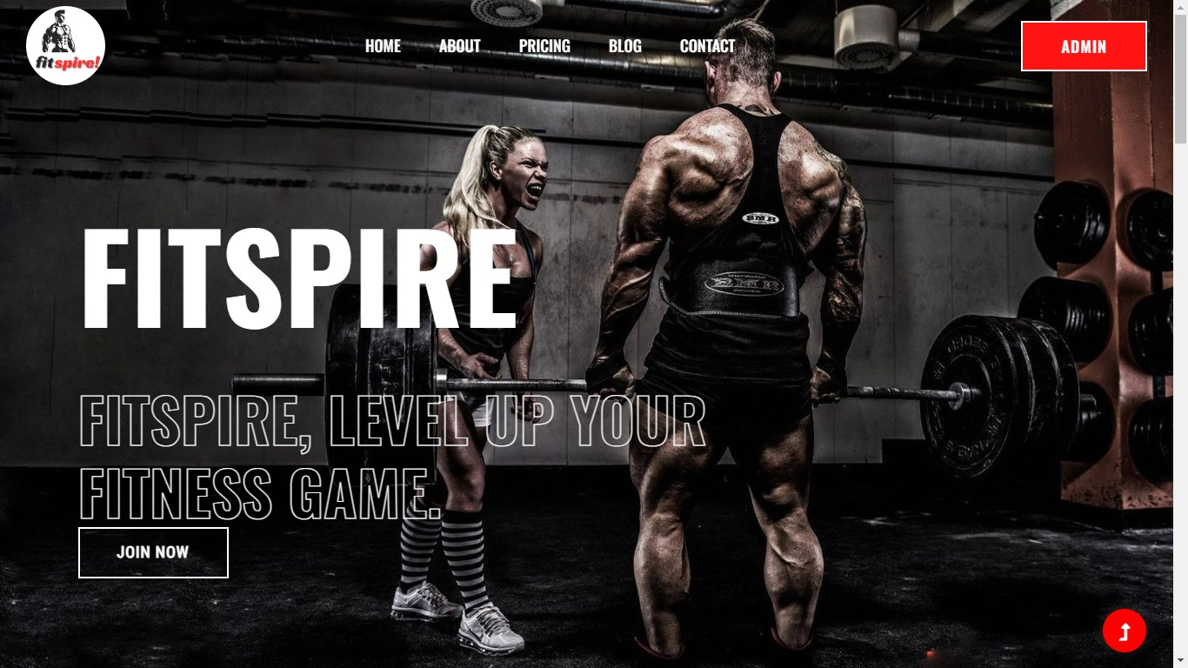

1. **what we offer.**

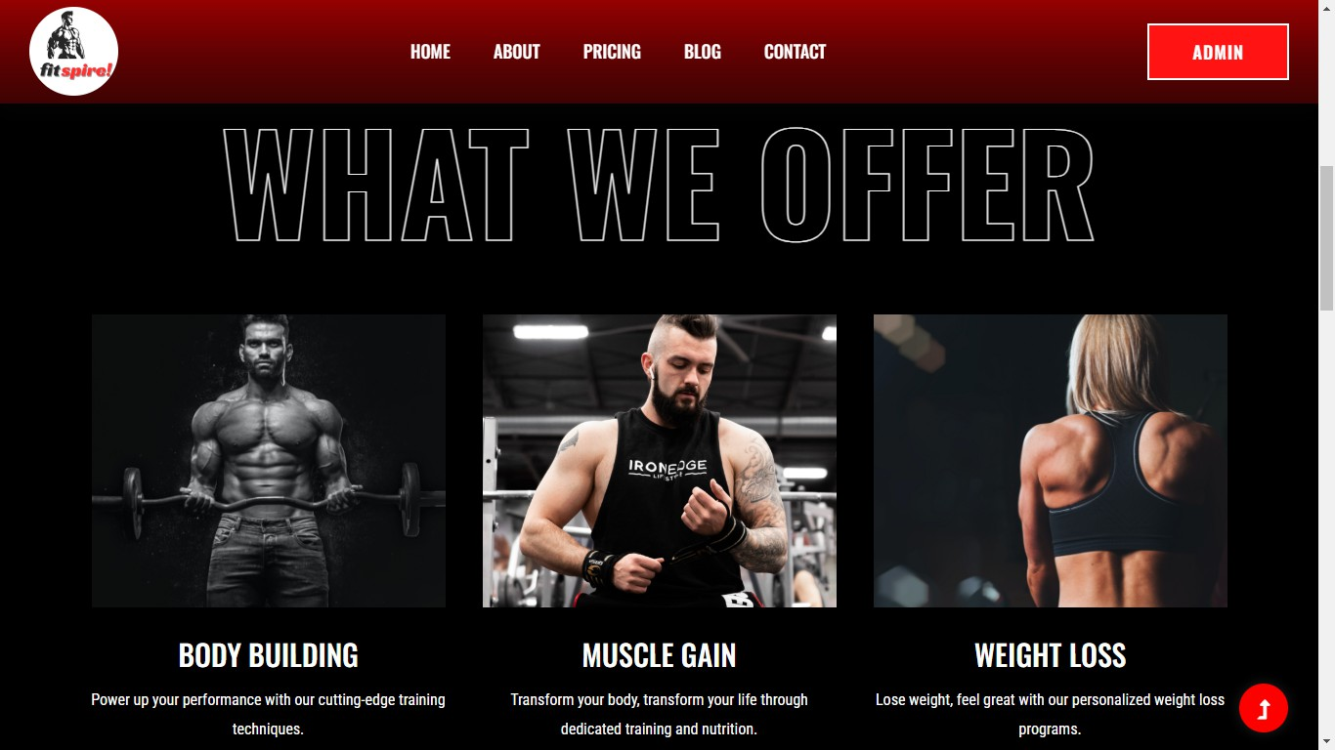

1. **Fitspire plans**

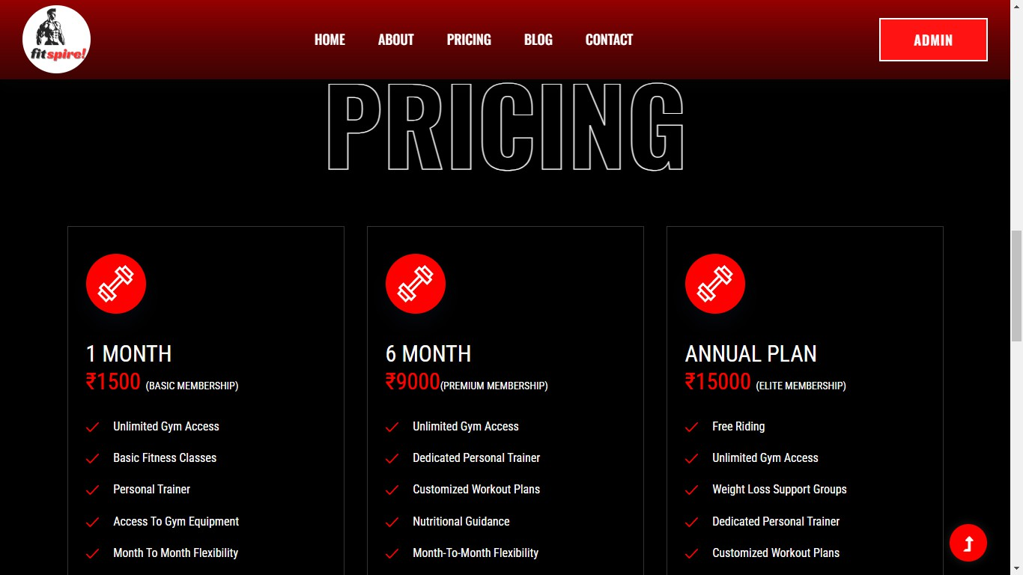

1. **About fitspire**

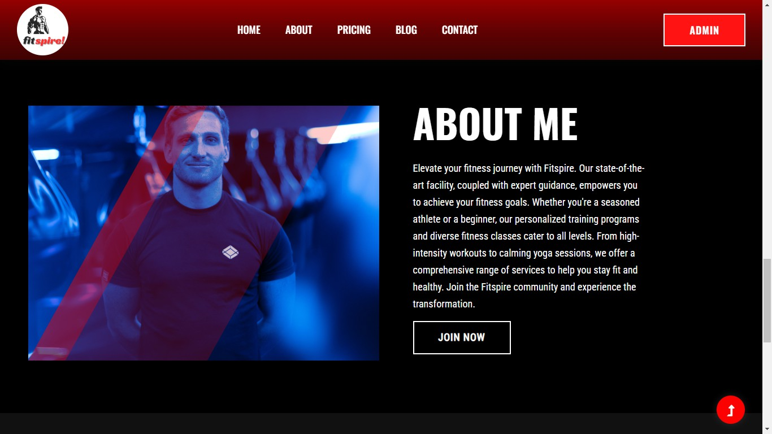

1. **pricing and plans**

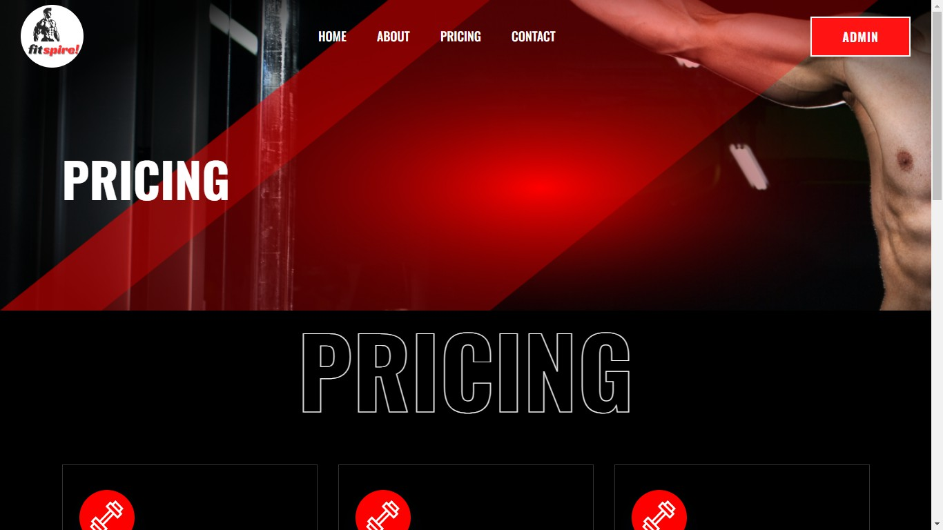

1. **Admin panel login**

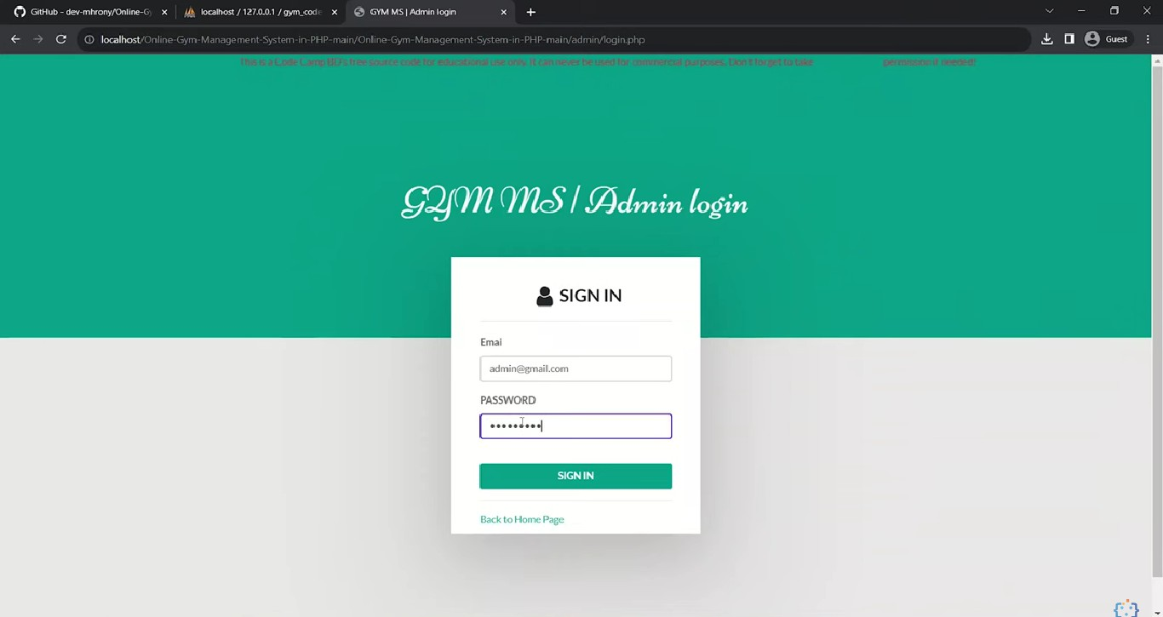

1. **Admin dashboard**

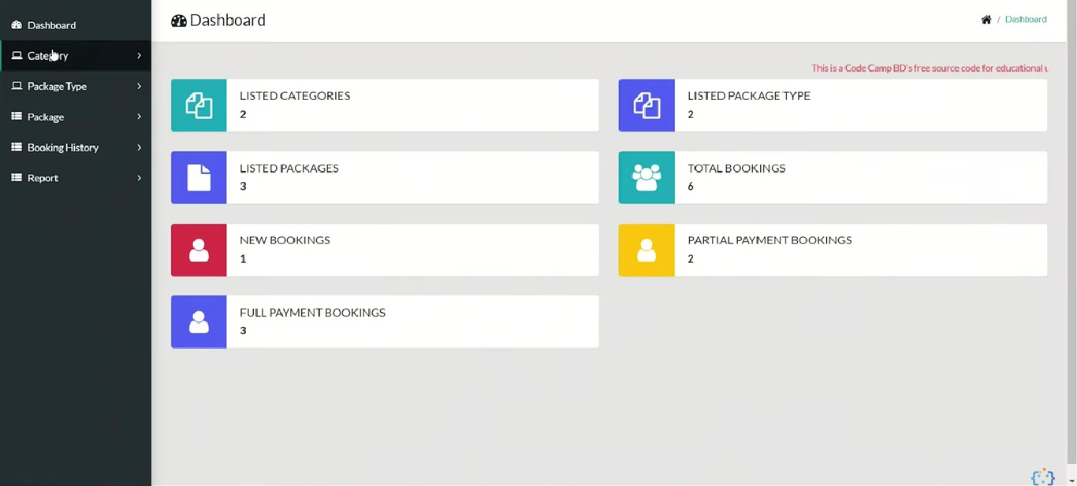

1. **Managing packages page**

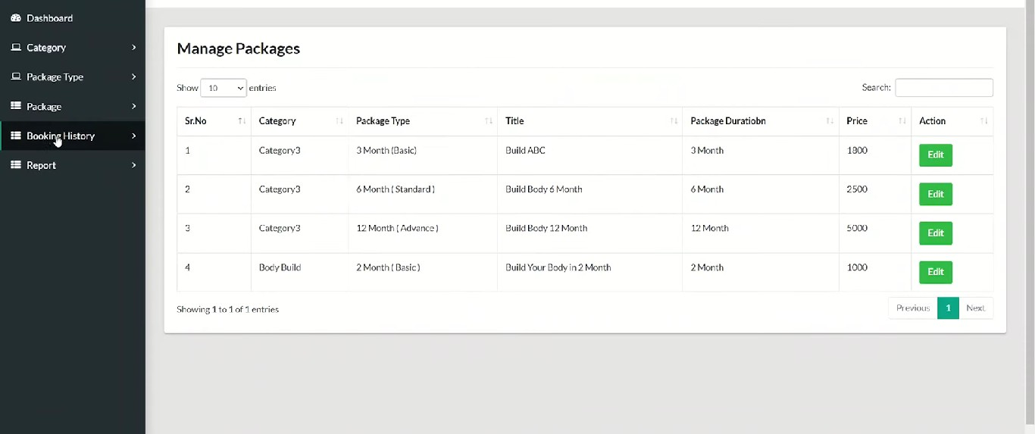

1. **New Bookings.**

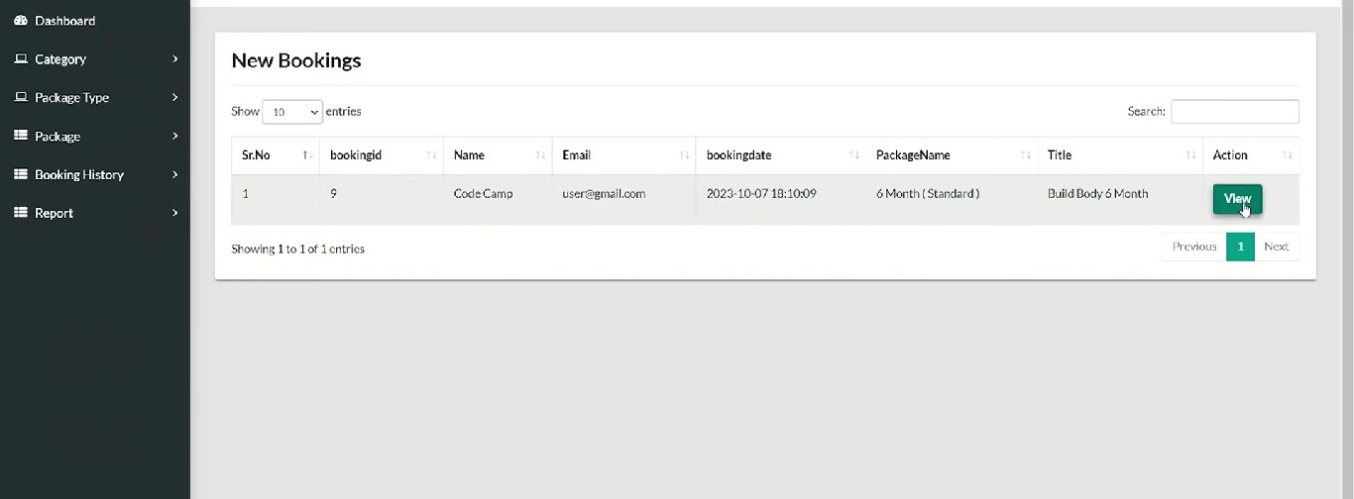

1. **Booking History.**

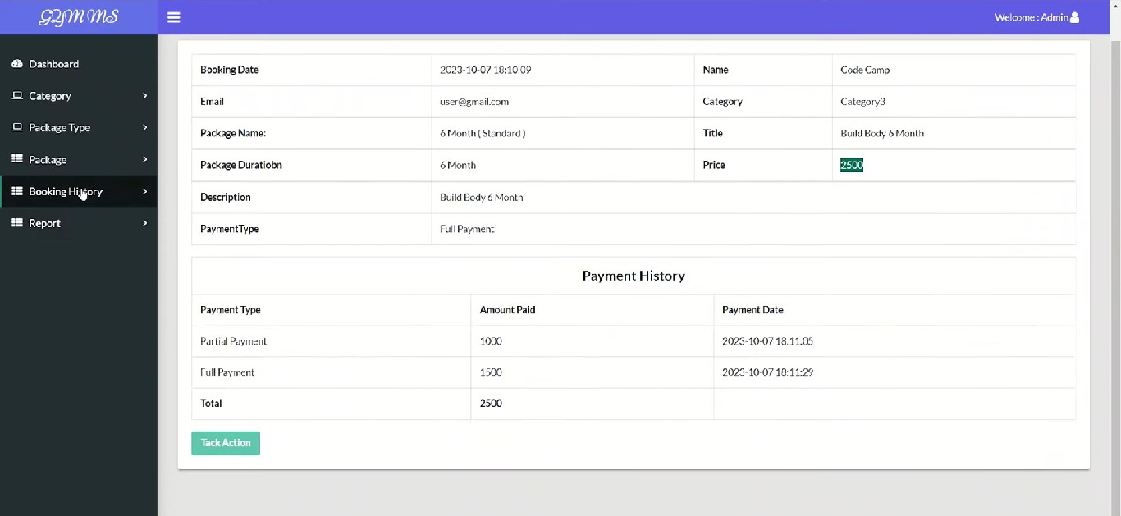

**CHAPTER 6**

**6.1 Unit Testing**

Unit testing is a testing technique in which modules are tested individually. Small individual units of source code are tested to determine whether it is fit to use or not. Different modules of games are put to test while the modules are being developed. Here modules refer to individual levels, players, scenes

**6.2 Integration Testing**

Integration testing is the technique in which individual components or modules are grouped together and tested. It occurs after testing. The inputs for the integrated testing are the modules that have already been unit tested.

**6.3 System Testing**

System testing is conducted on the entire system as a whole to check whether the system meets its requirements or not. software was installed on different systems and any errors or bugs that occurred were fixed.

**6.4 Acceptance Testing**

User Acceptance is defined as a type of testing performed by the Client to certify the system with respect to the requirements that was agreed upon. Thistesting happens in the final phase of testing before moving the software application to the Market or Production environment.

**Future scope of the project**

The health and fitness industry has become extremely diverse in the range of services and facilities it offers; varying from large scale leisure centres and gymnasiums, to individual personal trainers who travel from one client to the next in their cars., Some services specialize in offering structured classes, others are informal; some cater for a particular demographic, and others for anyone. Classes for Mature Older People This group of people can make up a great proportion of your clientèle. They generally do not like loud music, so keep it soft or at a medium level. Most also prefer low-key surroundings so avoid bright lights, mirrors, or posters of super-fit young people for example. Older participants are often more concerned about joint movement and flexibility than weight loss and can relate better to an older instructor who shows respect and individual attention to their requirements. It is very common that this type of population attends for social reasons - to meet others and relax. For Professional Athletes or Competitive Sports People This can be a hard group to cater for because they can vary considerably in the type of sports they are involved in, and elite athletes may require very specialised fitness components. The triathlete, swimmer, runner or aerobics-orientated person will want a hard, advanced class to challenge their fitness. The type of sport and the fitness components to be improved will indicate the type of training employed. You may find elite athletes require personal training, one-on-one, to best achieve their goals.

Personal training has become more and more popular over the past couple of decades, but it is expensive, and so tends to be limited to those who can afford it. However, it is a great way to increase motivation and to improve knowledge and technique with workouts. Personal trainers usually have up-to-date knowledge on the latest techniques and research done in the fitness industry. For a hefty fee, some companies offer a live-in personal training service for several months whereby the trainer lives with the exerciser and takes control of what they eat and how and when they exercise. Other services might involve a trainer accompanying an individual at their place of employment to oversee their diet and exercise. For Beginners These types of clients can generally be catered for a little easier than other groups. Generally, their cardiovascular fitness needs to be increased, and their basic fitness components of strength, flexibility and muscular endurance can be improved as well. Attending classes with easy-to-follow fitness routines will allow beginners to keep up and enhance their skills almost immediately. A basic low-impact class with a caring and understanding instructor will be a good start to any beginner’s fitness regime. For Children Younger persons are becoming more involved in fitness classes. Fitness classes for children are extremely important for the following reasons. There may be low levels of physical education training and sports education in schools. Increased concern for overweight and obese children and adolescents.

**Implementation**

Detailed Design of Implementation This phase of the systems development life cycle refines hardware and software specifications, establishes programming plans, trains users and implements extensive testing procedures, to evaluate design and operating specifications and/or provide the basis for further modification.

**Technical Design**

This activity builds upon specifications produced during new system design, addingdetailed technical specifications and documentation.

**Test Specifications and Planning**

This activity prepares detailed test specifications for individual modules and programs, job streams, subsystems, and for the system as a whole.

**Programming and Testing**

This activity encompasses actual development, writing, and testing of program units or modules. 116

**User Training**

This activity encompasses writing user procedure manuals, preparation of user training materials, conducting training programs, and testing procedures.

**Acceptance Test**

A final procedural review to demonstrate a system and secure user approval before a system becomes operational.

**Installation Phase**

In this phase the new Computerized system is installed, the conversion to new procedures is fully implemented, and the potential of the new system is explored.

**System Installation**

The process of starting the actual use of a system and training user personnel in its operation.

**Review Phase**

This phase evaluates the successes and failures during a systems development project, and to measure the results of a new Computerized T

**Development Recap**

A review of a project immediately after completion to find successes and potentialproblems in future work.

**Post-Implementation Review**

A review, conducted after a new system has been in operation for some time, to evaluate actual system performance against original expectations and projections for cost-benefit improvements. Also identifies maintenance projects to enhance or improve the system.

**CHAPTER 7**

**7.1 CONCLUSION**

After we have completed the project we are sure the problems in the existing system would overcome. The “**GYM MANAGEMENT SYSTEM**” process made computerized to reduce human errors and to increase the efficiency. The main focus of this project is to lessen human efforts. The maintenance of the records is made efficient, as all the records are stored in the database, through which data can be retrieved easily. The navigation control is provided in all the forms to navigate through the large amount of records. If the numbers of records are very large then user has to just type in the search string and user gets the results immediately. The editing is also made simpler. The user has to just type in the required field and press the update button to update the desired field.

The Members and Staffs are given a particular unique id no. So that they can be accessed correctly and without errors. Our main aim of the project is to get the correct information about a particular Member and Staffs available in the Gym website.

**CHAPTER 8**

**RESEARCH AND REFERENCE**

* 1. Matellio,”How to develop a Gym Management System for your Gym”,2023.Available at: [**https://www.matellio.com/blog/smart-gym-management-software-development**](https://www.matellio.com/blog/smart-gym-management-software-development)
  2. Oracle MySQL Documentation. *MySQL 8.0 Reference Manual*, Oracle Corporation, 2023. Available at: <https://dev.mysql.com/doc/>
  3. [**https://github.com/blakadder/templates**](https://github.com/blakadder/templates)

**GITHUB LINK:**

1. <https://github.com/Niranjan-githubs/dbms-test.git>
2. <https://github.com/NikashKG/Fitspire-DBMS.git>
3. [**https://github.com/NithishBalaji01/DBMS-Project.git**](https://github.com/NithishBalaji01/DBMS-Project.git)